

Practices for Secure Software Report

Table of Contents
Document Revision History 3
Client 3
Instructions 3
Developer 4
1. Algorithm Cipher 4
2. Certificate Generation 4
3. Deploy Cipher 4
4. Secure Communications 4
5. Secondary Testing 4
6. Functional Testing 4
7. Summary 4
8. Industry Standard Best Practices 4

Document Revision History

Version | Date | Author | Comments
1.0 |  | Osaretin Odigie

Client



Instructions

Submit this completed practices for secure software report. Replace the bracketed text with the relevant information. You must document your process for writing secure communications and refactoring code that complies with software security testing protocols.

- Respond to the steps outlined below and include your findings.
- Respond using your own words. You may also choose to include images or supporting materials. If you include them, make certain to insert them in all the relevant locations in the document.
- Refer to the Project Two Guidelines and Rubric for more detailed instructions about each section of the template.

Developer
Osaretin Odigie

Algorithm Cipher

To secure Artemis Financial’s application and protect customer data, I recommend using AES-256 for encryption and SHA-256 for hashing and checksum verification. Since Artemis Financial handles sensitive financial information, strong security is necessary to prevent data breaches and stay compliant with financial regulations. AES-256 is a block cipher that takes blocks of readable plaintext and scrambles them into unreadable ciphertext using a 256-bit key. While AES protects data privacy, SHA-256 is a cryptographic hash function that checks data integrity, ensuring information isn't altered while being sent between the server and the user.
While encryption and hashing work together, they serve different purposes. Encryption is two way, meaning authorized users can decrypt the data back into its original form using a key. Hashing with SHA-256 is strictly one-way. It takes an input string of any length and turns it into a fixed 256-bit output, which displays as a 64-character string. Even a tiny change to the original input, like changing one letter. Produces a completely different hash. Because a 256-bit hash has $2^{256}$ possible combinations, it is impossible for an attacker to reverse the hash to find the original input or find two different inputs that create the exact same hash.
Strong encryption also relies on unpredictable random numbers and the right types of keys. Standard random number generators in code follow a set pattern, so if a hacker figures out the starting point, they can guess future keys. Instead, secure systems use cryptographically secure random number generators to create unpredictable keys and Initialization Vectors, which ensure that encrypting the same data twice never produces the same output. As for keys, symmetric encryption like AES uses a single shared key to both lock and unlock data. It is very fast, though sharing that single key safely can be difficult. Asymmetric encryption solves this by using two keys, a public key shared openly to encrypt data, and a private key kept secret on the server to decrypt it. In HTTPS, both work together asymmetric keys safely set up the initial connection, and symmetric encryption quickly handles the rest of the web traffic.
The history of encryption shows why modern algorithms like AES-256 and SHA-256 are necessary today. Early encryption used simple letter swapping ciphers like the Caesar cipher or mechanical machines like the Enigma, which were eventually cracked as computers were invented. In the 1970s, the Data Encryption Standard became popular, but its 56-bit key became too small and easy for modern computers to brute force. This led to Triple DES and eventually AES in 2001. Similarly, older hashing algorithms like MD5 and SHA-1 used to be the standard, but researchers found ways to force hash collisions, making them unsafe. Today, AES-256 and SHA-256 are the trusted industry standards, and current security work is focused on post quantum encryption to prepare for future quantum computers.

Certificate Generation
Insert a screenshot below of the CER file.

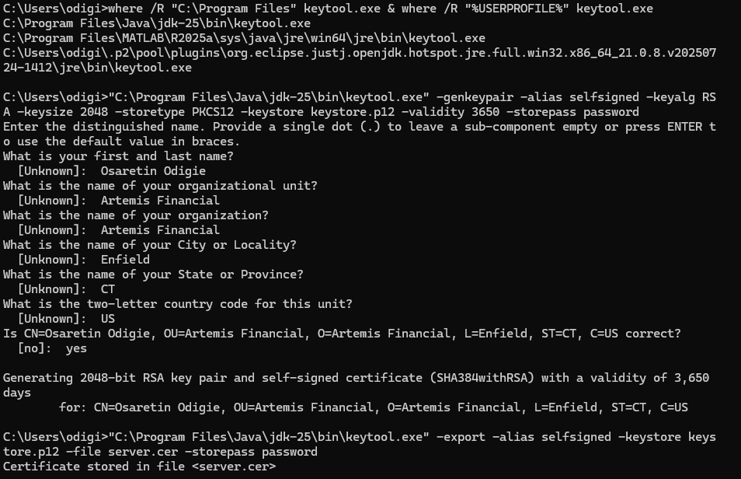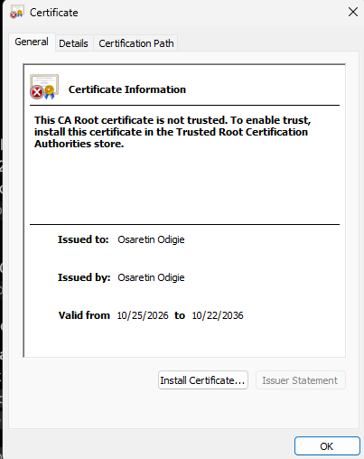

Deploy Cipher
Insert a screenshot below of the checksum verification.

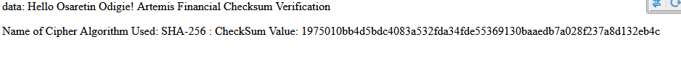

Secure Communications
Insert a screenshot below of the web browser that shows a secure webpage.

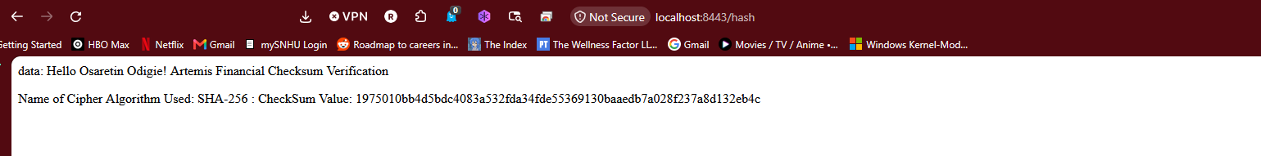

Secondary Testing
Insert screenshots below of the refactored code executed without errors and the dependency-check report.

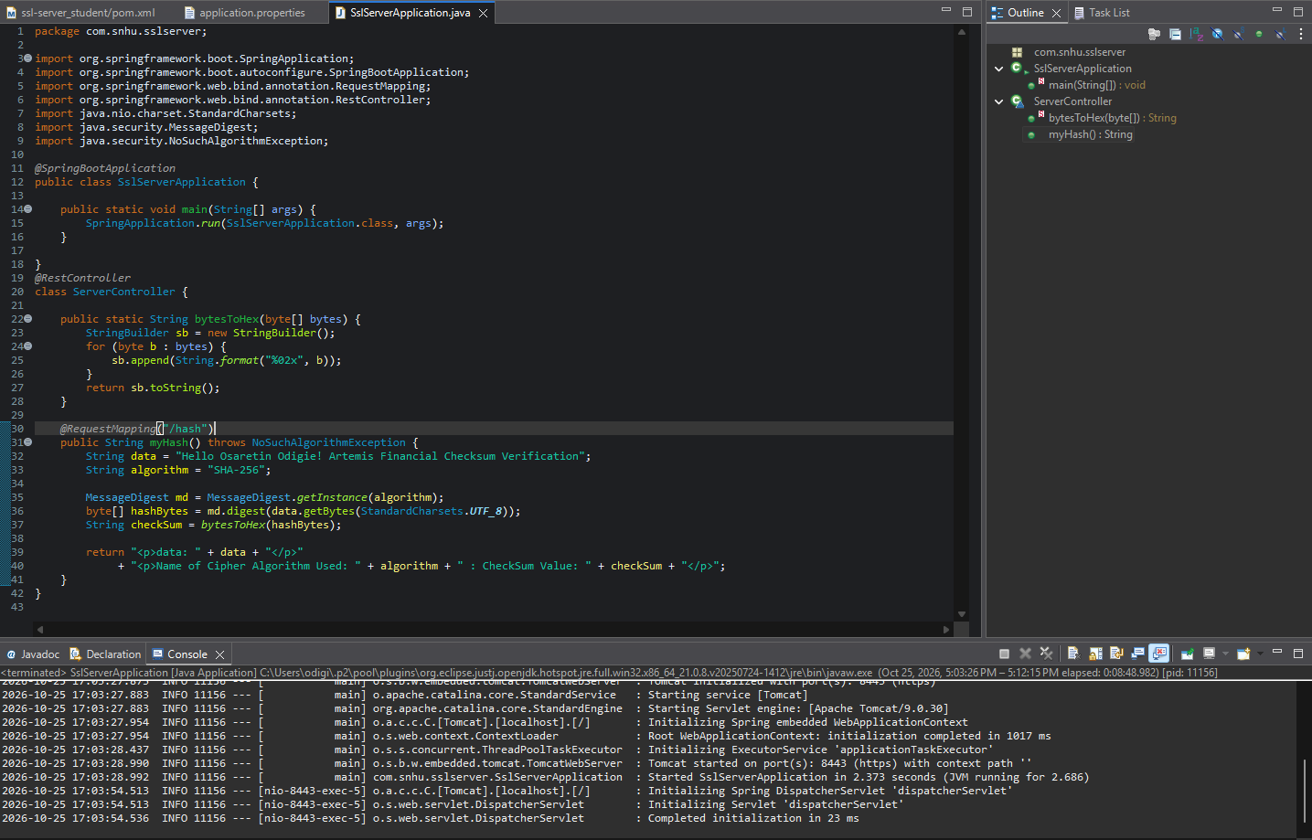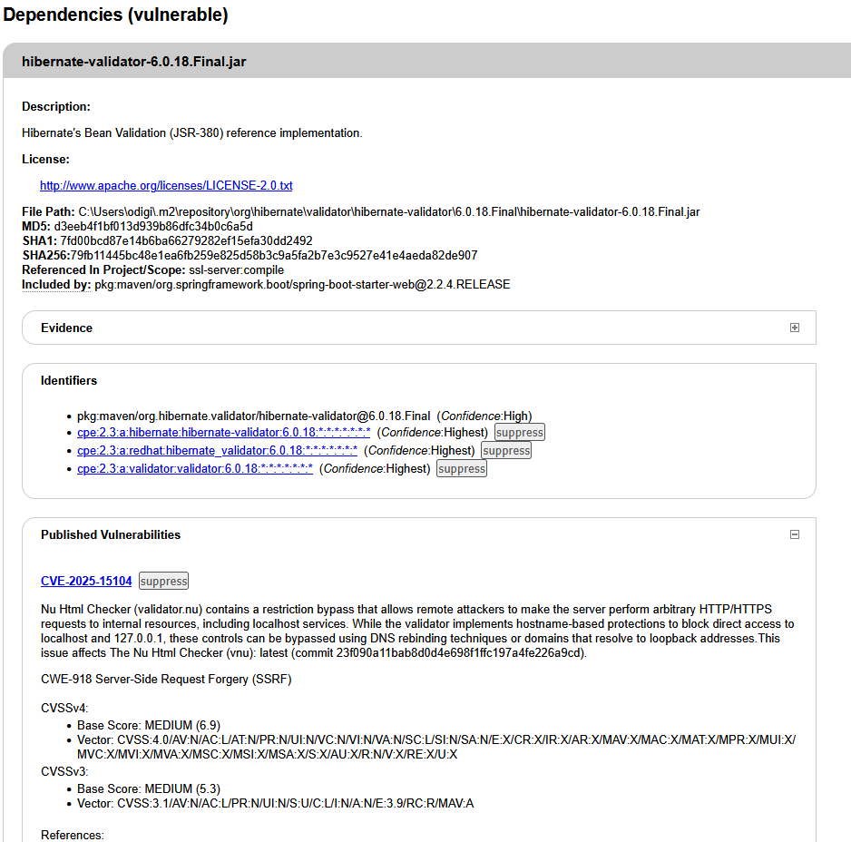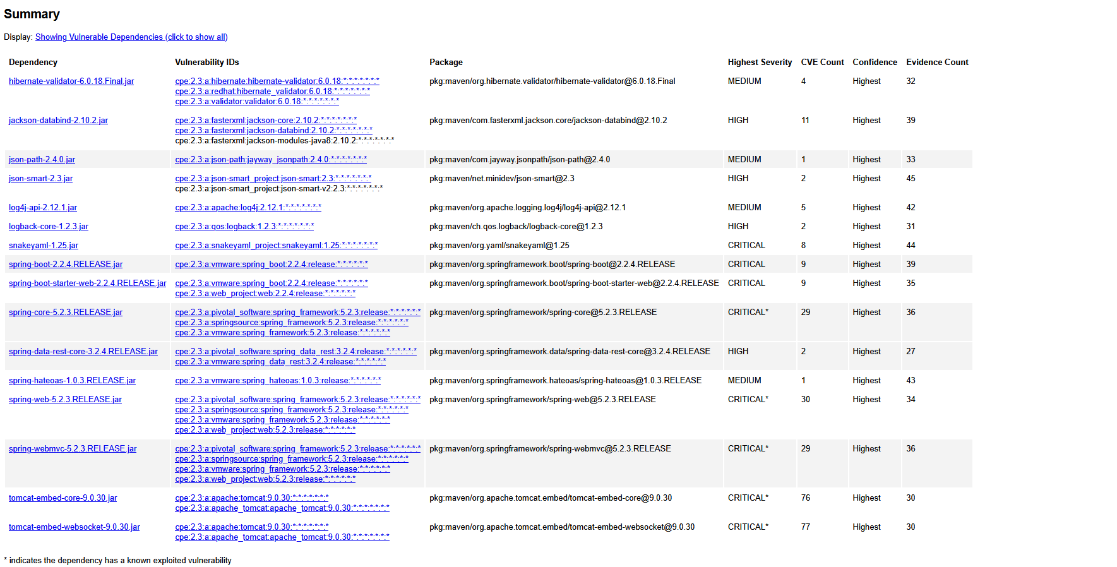

Functional Testing
Insert a screenshot below of the refactored code executed without errors.

Summary

My refactoring covered identifying initial security gaps, reviewing the code, fixing the vulnerabilities, and testing the final build. Originally, SslServerApplication.java only had the basic starter code with no way to verify data integrity, and application.properties only listed the project name, leaving the app on unencrypted HTTP. To fix this, I added a REST controller with a /hash endpoint that uses Java’s MessageDigest class to create a SHA-256 checksum for a string containing my name. I also used Java keytool to generate a self signed certificate and updated application.properties to run the server over HTTPS on port 8443.
To add layers of security to the application, I made sure not to rely on just one fix. First, I secured the code itself by adding SHA-256 hashing so any data shown on the /hash page has a verifiable checksum. Second, I secured the network connection by linking the SSL certificate to the server in application.properties, encrypting traffic between the browser and the server over HTTPS. Finally, I verified the build by running the OWASP Dependency Check tool in Maven and testing https://localhost:8443/hash in a browser to confirm the app ran cleanly with no new vulnerabilities.

Industry Standard Best Practices

While refactoring the code, I followed secure coding best practices to improve security without breaking the existing application. One major rule is to never write custom encryption algorithms from scratch, since custom math usually contains hidden bugs. Instead, I used Java’s built-in, well-tested MessageDigest library with UTF-8 encoding and proper error handling to generate the SHA-256 hash safely. I also kept the SSL settings such as the port number and keystore details inside application.properties rather than coding them into the Java file. Additionally, the /hash endpoint does not accept unverified user input, which helps prevent injection attacks, and I used the OWASP Dependency Check scanner to make sure our project libraries were safe.
Using these best practices brings clear value to Artemis Financial’s overall business. Because the company handles sensitive client finances, a single data breach could lead to heavy legal fines, lawsuits, and lost customer trust. Clients need to know their information is protected by reliable standards like HTTPS and SHA-256. Furthermore, catching and fixing security issues early during development through manual code reviews and static dependency scans. Saves the company a lot of time and money. Fixing an unencrypted endpoint or an outdated library in Eclipse takes minutes, whereas recovering from a real cyberattack in production can cost millions.

